

CMU-SE451 Capstone Project II
USER INTERFACE DESIGN DOCUMENT
Version 1
Date:
Help Find Lost Loved Ones

Submitted by

Vu, Truong Quang
Vinh, Tong Tran
Nhan, Tran Van
Thien, Le Van
Vu, Huynh Van

Approved by

Thuan, Nguyen Tan Ph.D

User Interface Review Panel Representative:

Name Signature Date

Capstone Project 2- Mentor:

Name Signature Date
PROJECT INFORMATION

Project acronym | HFLLO
Project title | Help Find Lost Loved Ones
Start date | 28 Feb 2023 | End Date | 20 May 2023
Lead institution | International School, Duy Tan University
Project mentor | Thuan Nguyen Tan, Ph.D.
Partner organization | Duy Tan University
Scrum Master | Vu, Truong Quang | truongquangvuu09@gmail.com | 0862 657 805
Team members | Vinh, Tong Tran | tongvinh.98.1906@gmail.com | 0985771298
Team members | Nhan, Tran Van | tranvannhan2362001@gmail.com | 0772019581
Team members | Thien, Le Van | thienpro1499001@gmail.com | 0965382571
Team members | Vu, Huynh Van | huynhdangvu241101@gmail.com | 0905131554

User Interface DOCUMENT
Document Title | User Interface Document
Author(s) | C2SE.33 Team
Role | C2SE.33-UserInterface-HFLLO
Date | April 05th, 2023 | File name: | C2SE.33-UserInterfac-HFLLO
URL
Access | Project and CMU Program

REVISION HISTORY
Version | Person(s) | Date | Description
1.0 | All members | April 05th, 2023 | release version 1.0

SIGNATURE
Document Approvals: The following signatures are required for approval of this document.
Mentor | Thuan, Nguyen Tan | Signature:
Mentor | Thuan, Nguyen Tan | Date:
Scrum master | Vu, Truong Quang | Signature:
Scrum master | Vu, Truong Quang | Date:
Team member(s) | Vinh, Tong Tran | Signature:
Team member(s) | Vinh, Tong Tran | Date:
Team member(s) | Nhan, Tran Van | Signature:
Team member(s) | Nhan, Tran Van | Date:
Team member(s) | Thien, Le Van | Signature:
Team member(s) | Thien, Le Van | Date:
Team member(s) | Vu, Huynh Van | Signature:
Team member(s) | Vu, Huynh Van | Date:

CONTENTS
1. Introduction 6
1.1. Purpose 6
1.2. Related Documents 6
1.3. Scope 6
2. List of User Interface for Sprint 6
3. Describe User Interface 8
3.1. UI-01: Sign In 8
3.2. UI-02: Sign Up 9
3.3. UI-03: Forgot Password 10
3.4. UI-04: Change the Password 10
3.5. UI-05: Home Page 11
3.6. UI-06: Introduce 14
3.7. UI-07: Service 16
3.8. UI-08: Shop 19
3.9. UI-09: Product Details (Description) 20
3.10. UI-10: Product Details (Reviews) 22
3.11. UI-11: News 23
3.12. UI-12: Highlights News Details 24
3.13. UI-13: Contact 25
3.14. UI-14: Booking 27
3.15. UI-15: Details Of Pre-booked Services 28
3.16. UI-16: Pay 28
3.17. UI-17: Sales 31
3.18. UI-18: Product Management (View) 32
3.19. UI-19: Product Management (More Products) 33
3.20. UI-20: Product Updat 34
3.21. UI-21: News Management (View) 35
3.22. UI-22: News Management (More Posts) 36
3.23. UI-23: News Update 37
3.24. UI-24: Order 38
3.25. UI-25: Order Details 39
3.26. UI-26: Profile 40

Introduction

Purpose
The purpose of the proposal is to:
- Find Lost Relatives puts you in contact with family members you may have never met, never knew existed or never thought you’d see again.
- When you feel the time is right, we’ll trace whoever you’re looking for and give you the emotional support you need to finally fill that hole in your life.
- Maybe it’s a parent who you haven’t seen since you were a child. Or a sibling that disappeared without a word more than a decade ago. It could even be an auntie that you lost touch with in the last couple of years. Whatever your situation, and whoever you’re looking for, perhaps you’ve got the feeling that things aren’t quite right. And you’re considering finding them so you can reach out and make things better. Every situation is different, but there’s something that stays the same in every story… When you know someone’s missing, you get that nagging feeling of wanting to find them. Because how are you supposed to deal with the fact that a family member is out there living life without you? When the table feels that little bit emptier every birthday or New Years?
- Currently, You go through phases where it’s fine and you carry on as normal. But then you can get that familiar feeling of sadness – like you’re lost – which hits you time after time. When you try to repress the feelings, do you notice that they nearly always rear their head again? And even if you’re unsure about getting in touch or you don’t think it’s the right time.
- Unfortunately, life sometimes gets in the way of our plans. The sooner you try to make contact, the more likely it is that your family member is out there waiting for your call.
- Although it may take time to build up the courage you need to take the first step – that’s okay. After all, this could be one of the biggest decisions you ever make in your life. We’ll be here whenever you’re ready.
- The above statements make it clear to us that if you’re curious about how you can take the first step, we can jump on a call, learn a bit more about your story, talk you through your options and find out whether we can help you get in contact with the person you’re looking for.

Related Documents
No | References | Document Information
1 | Product Backlog document | Product Backlog
Table 1. Related Documents

Scope
- This document provides an overview of how the project will be developed. It includes a product overview, a process overview, and a project team overview.
- In addition, this project is being supervised by the university environment and it is carried out with limited cost and time. So the goal of this project is to be released with all the basic functionality outlined from the start.
- Through the project, conflicts between team members, problems occurring during the development phase, will be a great contribution for all members in learning and developing technical skills. such as coding, testing, design.

List of User Interface for Sprint
Roles | User Interface ID | UI Name | Description | Notes
User | UI-01 | Comment | User can comment into post or media video
User | UI-02 | Search post | User can search post by keyword
User | UI-03 | Register to find relatives | User can register to find relatives
User | UI-04 | Advanced search | User can search by information
User | UI-05 | Search by lost situation | User can search post by lost situation
User | UI-06 | Search for loved ones by pictures | User can find lost people by pictures
User | UI-07 | Searching for loved ones by objects | User can find lost people by pictures of objects
User | UI-08 | chat with admin | User can chat with admin page
User | UI-09 | chat by zalo | User can chat with Admin by Zalo
User | UI-10 | search news | User can search news by keyword
Admin | UI-11 | edit post | Admin can edit the post
Admin | UI-12 | delete post | Admin can delete the post
Admin | UI-13 | add new post | Admin can create the new post
Admin | UI-14 | add new news | Admin can create the new news
Admin | UI-15 | edit news | Admin can edit the news
Admin | UI-16 | delete news | Admin can delete the news
Admin | UI-17 | add video media | Admin can create the new video media
Admin | UI-18 | edit video media | Admin can edit the video media
Admin | UI-19 | delete video media | Admin can delete the video media
Admin | UI-20 | Edit Advanced search | Admin can edit the advanced search
Admin | UI-21 | add the search information according to the lost situation | Admin can add new search information according to the lost situation
Admin | UI-22 | edit the search information according to the lost situation | Admin can edit the search information according to the lost situation
Admin | UI-23 | restore photos to the past | Admin can restore photos of lost people to the past
Table 2. List of User Interface for Sprint

Describe User Interface

UI-01: Comment

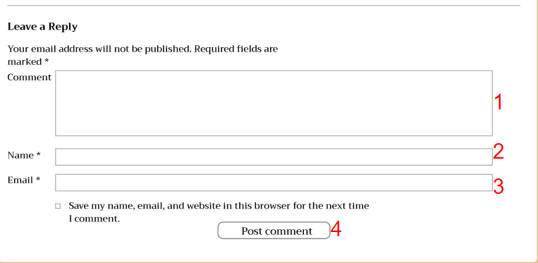
Figure 1. Comment

From | Condition | Control Type | Target | Notes
1 | Input | Textbox | Input Comment
2 | Input | Textbox | Input Name
3 | Input | Textbox | Input Email
4 | Click | Button | Click to post the comment

3.2. UI-02: Search-post
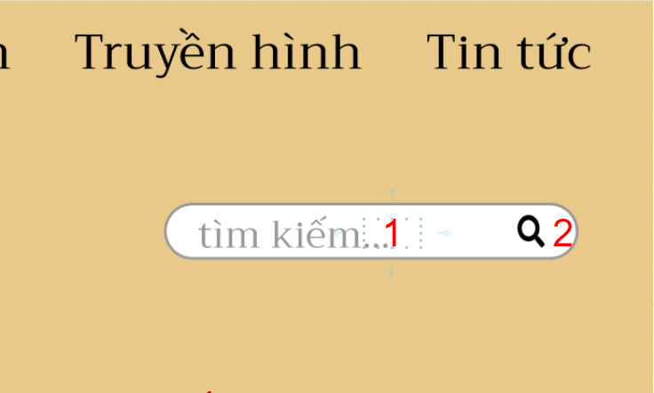
Figure 2. Search post
From | Condition | Control Type | Target | Notes
1 | Input | Textbox | Input keyword
2 | Click | Button | Click to search by keyword

3.3. UI-03:Register to find relatives
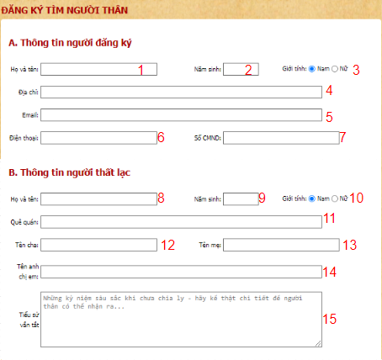
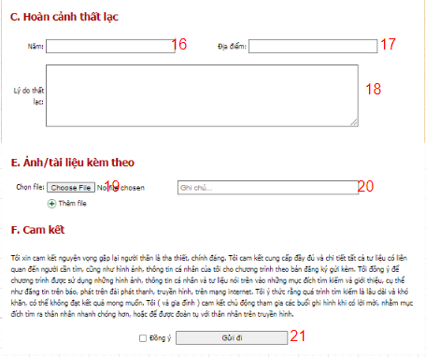
Figure 3. Register to find relatives
From | Condition | Control Type | Target | Notes
1 | Input | Textbox | Input Name subscribers
2 | Input | Textbox | Input Year of Birth subscribers
3 | Radio Button | Click | Click to choose subscribers gender
4 | Input | Textbox | Input Address subscribers
5 | Input | Textbox | Input Email subscribers
6 | Input | Textbox | Input Phone Number subscribers
7 | Input | Textbox | Input Citizen identification subscribers
8 | Input | Textbox | Input Name of of the person looking for
9 | Input | Textbox | Input Year of Birth of the person looking for
10 | Radio Button | Click | Click to choose gender lost person
11 | Input | Textbox | Input hometown of the person looking for
12 | Input | Textbox | Input father’s Name  of the person looking for
13 | Input | Textbox | Input mother’s Name of the person looking for
14 | Input | Textbox | Input brother's Name of the person looking for
15 | Input | Textbox | Input Short story of the person looking for
16 | Input | Textbox | Input Lost Year
17 | Input | Textbox | Input Address
18 | Input | Textbox | Input Lost reason
19 | Button | Click | Click to choose file picture
20 | Input | Textbox | Input Note
21 | Button | Click | Click to submit the form

3.4. UI-04: Advance search
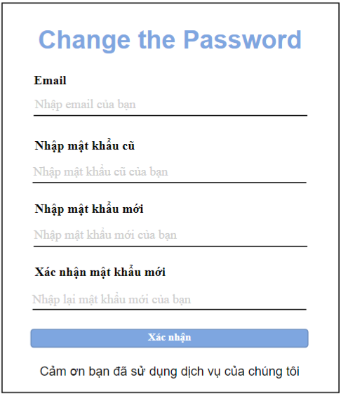
1
2
3
4
5
Figure 4. Change the Password
From | Condition | Control Type | Target | Notes
1 | Input | Textbox | Input email
2 | Input | Textbox | Input old password
3 | Input | Textbox | Input new password
4 | Input | Textbox | Input confirm new password
5 | Click | Button | Click to confirm

3.5. UI-05: Search by lost situation

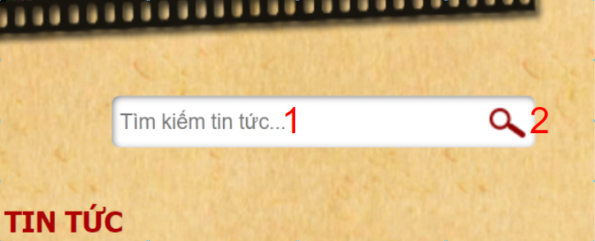
6
7
8
9
10
2
3
Figure 5. Search by situation

From | Condition | Control Type | Target | Notes
1 | Input | Input | Input situation of lost person
2 | Click | Button | Click to search post

3.6. UI-06: Search for loved ones by pictures

Figure 6. Search for loved ones by pictures
From | Condition | Control Type | Target | Notes
1 | Click | Button | Click to book now

3.7. UI-07: Searching for loved ones by objects

Figure 7. Searching for loved ones by objects
From | Condition | Control Type | Target | Notes
1 | Click | Button | Click to view reflexology package details
2 | Click | Button | Click to see body pack details
3 | Click | Button | Click to view deep cleaning package details
4 | Click | Button | Click to see package details of treatments
5 | Click | Button | Click for details of facial treatment package
6 | Click | Button | Click to see the details of the therapeutic massage package
7 | Click | Button | Click buy to buy massage service package
8 | Click | Button | Click buy to buy face sevice package

3.8. UI-08: Chat with admin
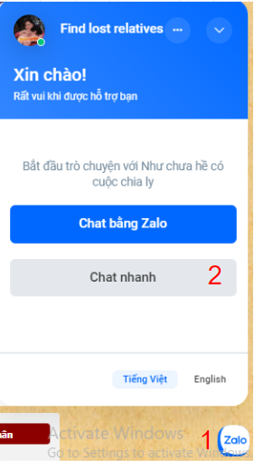
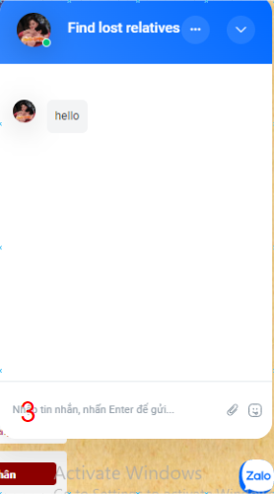
Figure 8. Chat with admin

From | Condition | Control Type | Target | Notes
1 | Click | Button | Click Button to open chat form
2 | Click | Button | Click Button to open chat form
3 | Input | Textbox | Input message

3.9. UI-09:Chat by Zalo
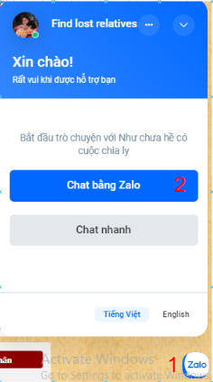
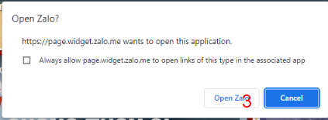

Figure 9. Chat by Zalo

From | Condition | Control Type | Target | Notes
1 | Click | Button | Click Button to open chat form
2 | Click | Button | Click Button to open chat form
3 | Click | Button | Click open to open Zalo chat

3.10. UI-10: Search news
Figure 10. Search news
From | Condition | Control Type | Target | Notes
1 | Input | Textbox | Input keyword of news
2 | Click | Button | Click to search news

3.11. UI-11: edit post
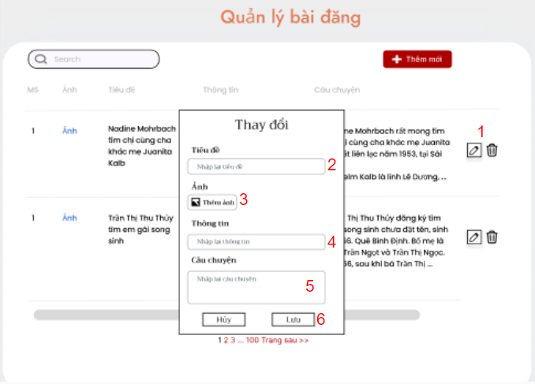
Figure 11. edit post
From | Condition | Control Type | Target | Notes
1 | Click | Button | Click to edit the post
2 | Input | Textbox | Input title of post
3 | Click | Button | Click to add the image
4 | Input | Textbox | Input information
5 | Input | Textbox | Input story
6 | Click | Button | Clock to save edit

3.12. UI-12: Delete post
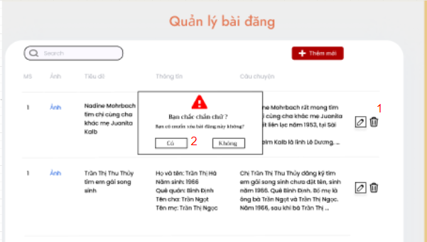
Figure 12. Delete post
From | Condition | Control Type | Target | Notes
1 | Click | Button | Click to delete the post
2 | Click | Button | Click to confirm delete the post

2
5
6
8
7
9
3.13. UI-13: Add new post
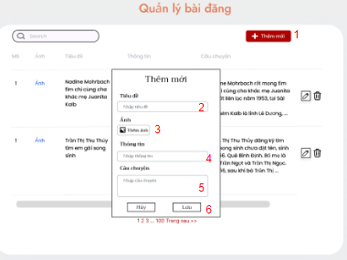
Figure 13. Add new post

From | Condition | Control Type | Target | Notes
1 | Click | Button | Click to create new post
2 | Input | Textbox | Input title of post
3 | Click | Button | Click to add the image
4 | Input | Textbox | Input information
5 | Input | Textbox | Input story
6 | Click | Button | Clock to save new post

3.14. UI-14: Add new news
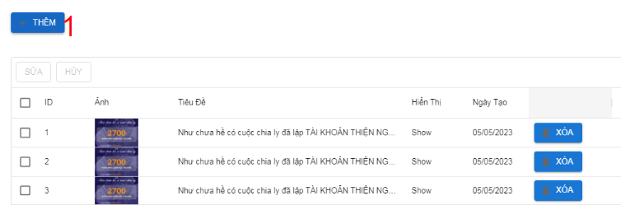
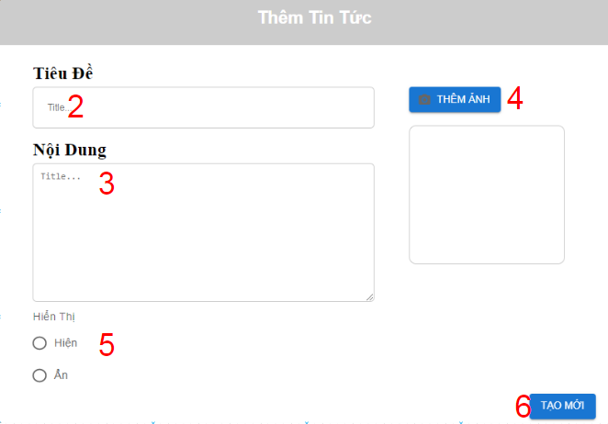
Figure 14. Add new news

From | Condition | Control Type | Target | Notes
1 | Click | Button | Click to open form
2 | Click | Input | input title
3 | Click | Input | input content
4 | Click | Button | Click to choose image
5 | Click | Check Box | Click checkbox
6 | Click | Button | Click button

3.15. UI-15: Edit news
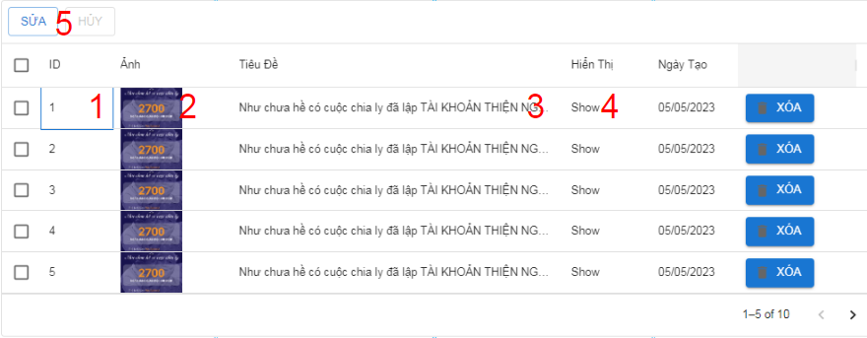
Figure 15. Edit news

From | Condition | Control Type | Target | Notes
1 | Click | Input | Input ID
2 | Click | Button | Click to Choose image to upload
3 | Click | Input | input content
4 | Click | Input | change display
5 | Click | Button | click to Save change

3.16. UI-16: Delete news
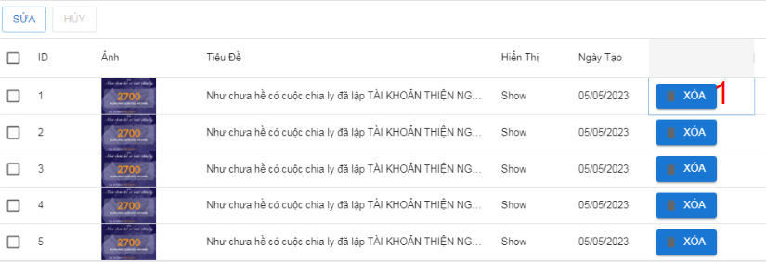
Figure 16. Delete news

From | Condition | Control Type | Target | Notes
1 | Click | Button | Click to delete news

3.17. UI-17: Add video media
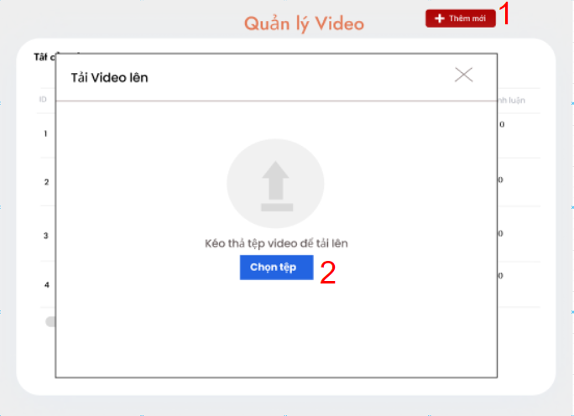
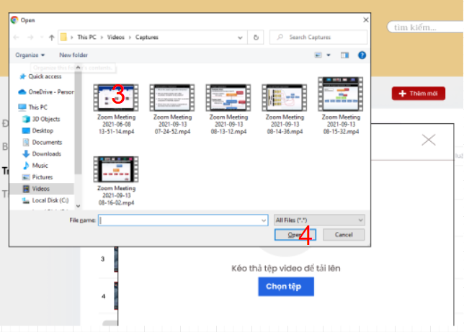
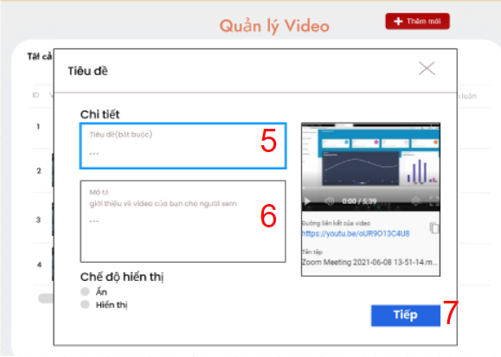
Figure 17. Add video media
From | Condition | Control Type | Target | Notes
1 | Click | Button | Click to create new video media
2 | Click | Button | Click to open list video
3 | Click | Button | Click to choose video to upload
4 | Click | Button | Click to upload video
5 | Input | Textbox | Input title of video media
6 | Input | Textbox | Input short description of video media
7 | Click | Button | Click to confirm upload video
8 | Click | Button | Click to finished uploading video

3.18. UI-18: Edit video media
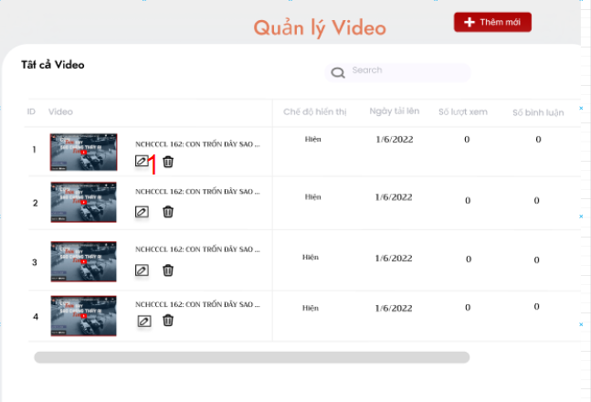
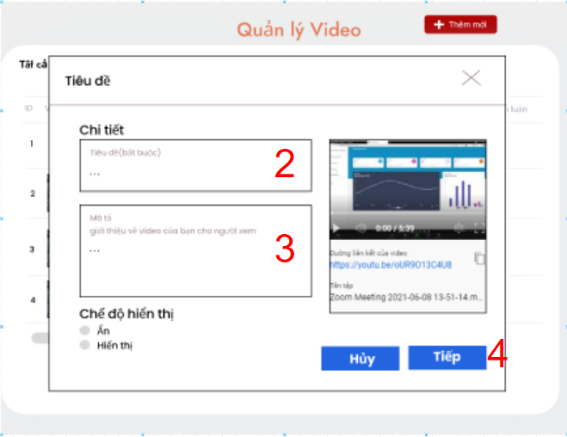
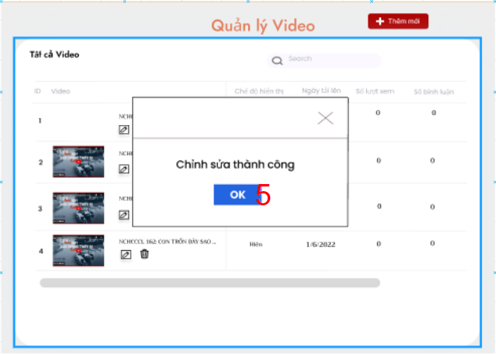
Figure 18. Edit video media
From | Condition | Control Type | Target | Notes
1 | Click | button | Click button to open edit form
2 | Input | Textbox | Input title of video media
3 | Input | Textbox | Input short description of video media
4 | Click | Button | Click to confirm edit video media
5 | Click | Button | Click to finished edit video media

3.19. UI-19: Delete video media
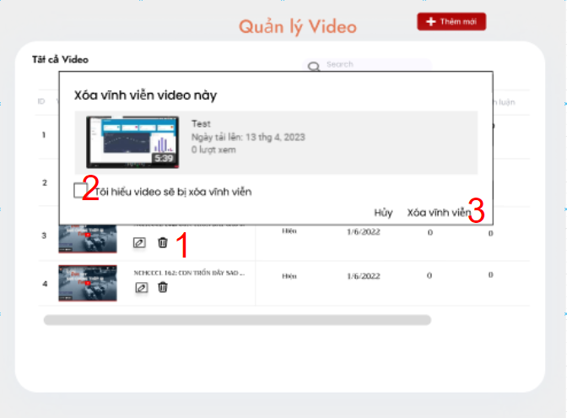
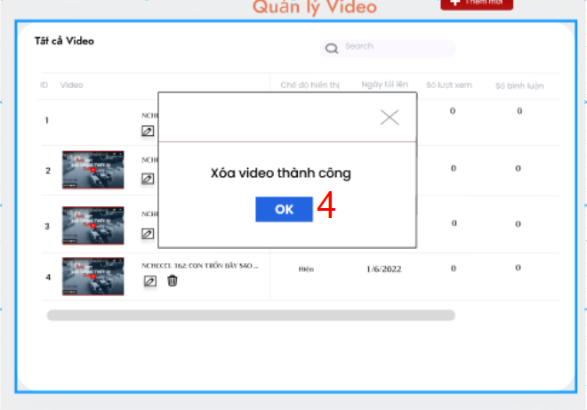
Figure 19. Delete video media
From | Condition | Control Type | Target | Notes
1 | Click | Button | Click to open delete form
2 | Click | CheckBox | Click to confirm delete video media
3 | Click | Button | Click to delete video media
4 | Click | Button | Click to finishing

3.20. UI-20: Edit search Advance

Figure 20. Edit search advance

From | Condition | Control Type | Target | Notes

3.21. UI-21: Add the search information according to the lost situation
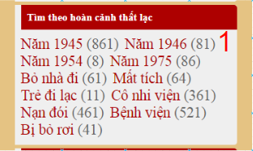
Figure 21. Add the search information according to the lost situation
From | Condition | Control Type | Target | Notes
1 | Click | Button | Click to search information according to lost situation

3.22. UI-22: Edit the search information according to the lost situation

Figure 22. Edit the search information according to the lost situation
From | Condition | Control Type | Target | Notes

